**Field Visiting Business Interview for**

**Digital Marketing**

**1. Empathy Mapping**

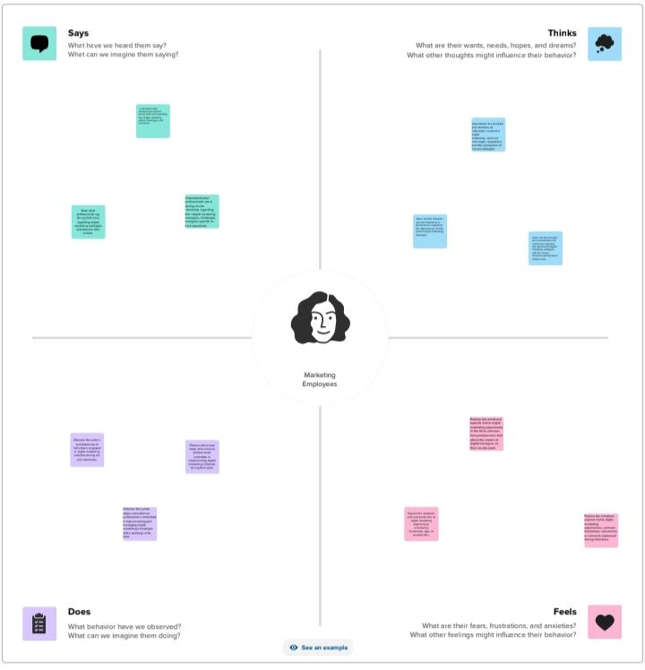

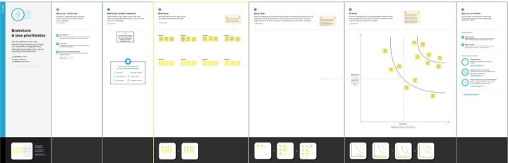

**2.Company Logo**



**3.Brand**

Field visiting business for Digital Marketing

**4.Email I'd**

Company's Mail I'd

[techsqardboss@gmail.com](mailto:techsqardboss@gmail.com)

Team Mail I'd

[digitalmarketingteam@gmail.com](mailto:digitalmarketingteam@gmail.com)

**5.Requesting letter for company**

Screenshot

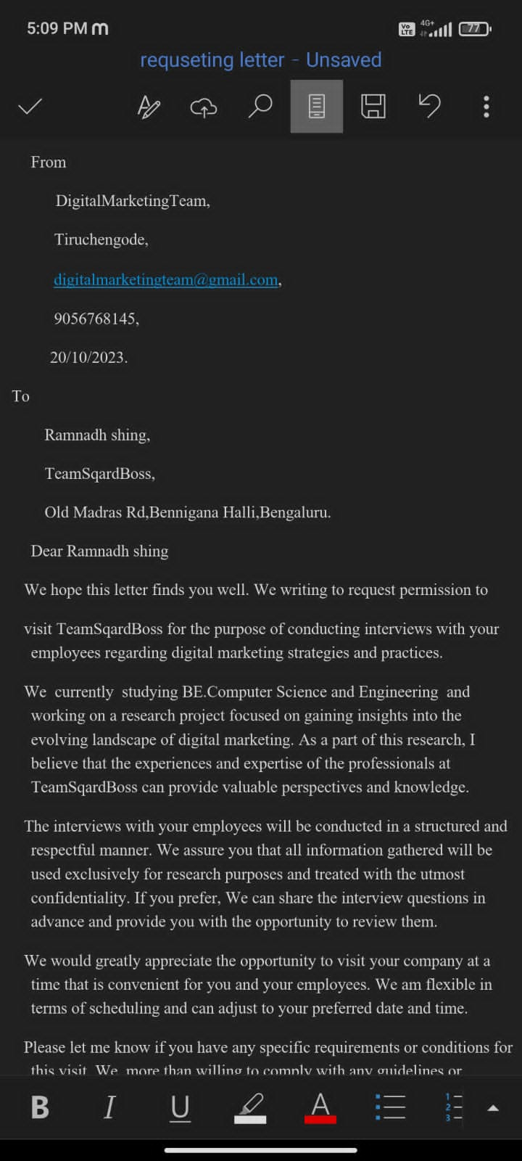

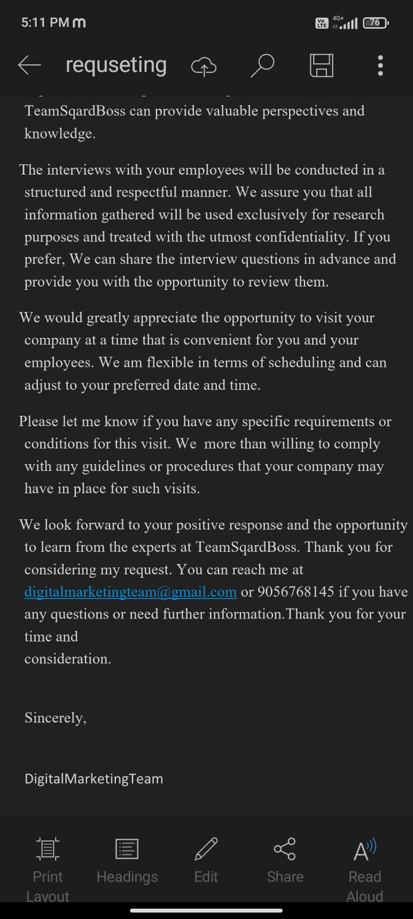

Requesting Letter mail for the company to approval for industrial visit

